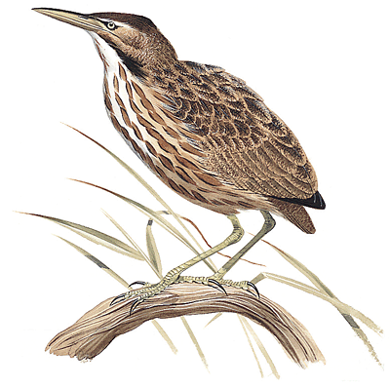
OUSE AND HUMBER DRAINAGE BOARD
A public body delivering flood risk, water level and habitat management in Yorkshire and the Humber
Job Application Form
Personal Details
Title
Surname
First Names
House / Flat Number or Name
Address Line 1
Address Line 2
Town
County or Region
Country
Postcode
Landline Number
Mobile Number
Email Address
If appointed, will you be able to produce a passport showing that you are a British Citizen or have a right of abode to stay/work in the UK, or an original document showing your National Insurance number or birth certificate? | YES/NO*
Do you hold a current driving licence? | YES/NO*
Do you have or have you been notified of an endorsement for an offence while driving? (Penalty Points) | YES/NO/NA*
Do you have any unspent criminal convictions? ** | YES/NO*

*Delete as appropriate
**As defined in the Rehabilitation of Offenders Act 1974
Education, Training and Professional Memberships
University of College | Qualification Gained | Date
Other Qualifications, Training of CPD | Qualification Gained | Date
Professional Body | Level | Date

Employment History
Employer | Position and Summary of Role and Achievements | Year Start /Finish
Other
Are there any adjustments that may be required to be made should you be invited for interview?
If so, please state here:

References
Please provide two people who can provide references – one of whom should preferably by your present / most recent employer.
Referee 1
Name
Position
Organisation
Building Number or Name
Address Line 1
Address Line 2
Town
County or Region
Country
Postcode
Contact Telephone Number
Email address
Referee 2
Name
Position
Organisation
Building Number or Name
Address Line 1
Address Line 2
Town
County or Region
Country
Postcode
Contact Telephone Number
Email address

Other Information
If there is insufficient room on this form to provide the information requested you may continue a blank sheet. Do not include a CV.
Data Protection Statement
The information that you provide on this form and that obtained from other relevant sources will be used to process your application for employment. The personal information that you give us will also be used in a confidential manner to help us monitor our recruitment process.
If you succeed in your application and take up employment with us, the information will be used in the administration of your employment with us and to provide you with information about us or third party via your payslip. We may also use the information if there is a complaint or legal challenge relevant to this recruitment process.

We may check the information collected, with third parties or with other information held by us. We may also use or pass to certain third parties information to prevent or detect crime, to protect public funds, or in other ways as permitted by law.

Declaration

By signing the application form you agree to the processing of sensitive personal data, (as described above), in accordance with our registration with the Data Protection Commissioner.

I understand that any false or misleading information given in this application may result in my dismissal if I am appointed. I declare that to the best of my knowledge all the foregoing information and that submitted in any accompanying document(s) is correct.

Applicants Signature_____________________

Date___________________________________

Please return this form under cover and marked confidential with the completed Equality and Diversity Monitoring form to:

Human Resources Manager
Ouse and Humber Drainage Board
91 Bridgegate
Howden
Goole
East Yorkshire
DN14 7JJ

