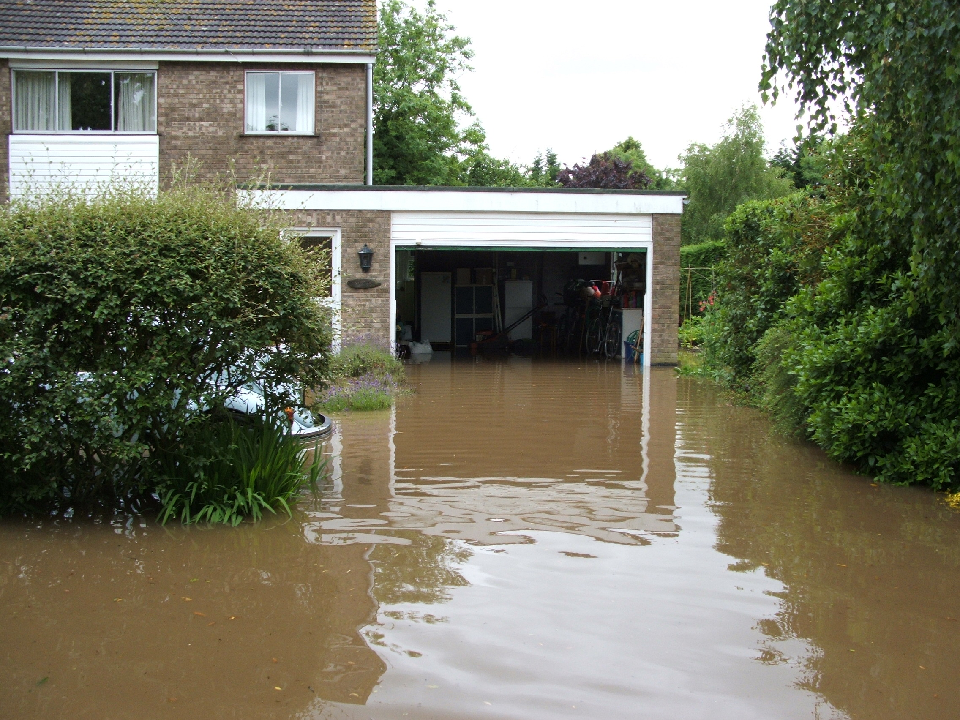

Emergency Flood Response Plan

for the ........................... IDB

Original issue number | 1.1

Original issued by
Original Issue for use only by | EFR Team
Version number | 1
Version issue date | 1 January 2011
Supersedes version | n/a
Prepared by
Full duplicate(s) held at | n/a

This template should be personalised for each IDB

Index

Read Me First Section
- Introduction
- Command and Control
- Objective and key principals
- Plan assumptions
- Plan Distribution
- Invocation Procedure
- Recovery Strategy
- Testing and Maintenance

Emergency Response Section
- Summary
- Action Task Lists

Appendices
- One – Contacts List
- Two – Emergency Flood Plan Team Roles
- Three – District Maps
- Four – Flood and Weather warnings
- Five – Silver Control Support Plan

Introduction

The Emergency Flood Response Plan (EFRP)

This EFRP provides overall guidance to the Board’s Officers when responding to any significant incident. It works at the worst case level.

The main aim of the plan is to ensure that there are adequate systems in place to enable the Board to respond to an emergency situation and to support other agencies and emergency services where appropriate.

The plan also focuses on how officers should handle the issues that will arise after an incident has occurred. This is illustrated as follows:

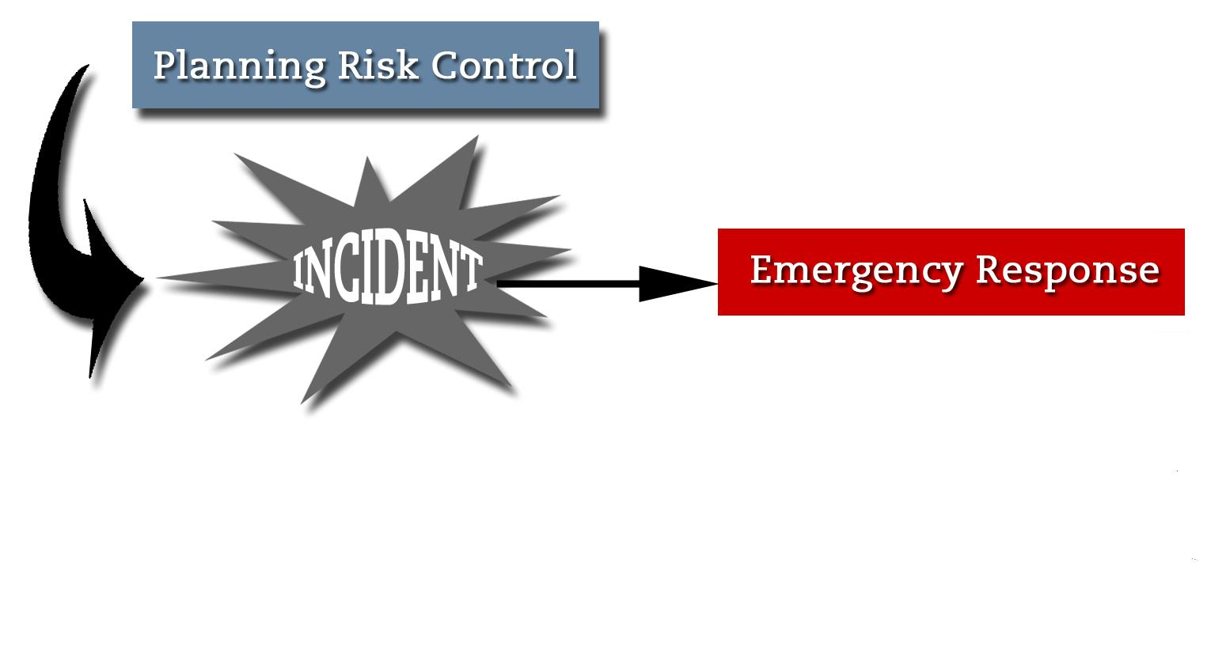
To some extent the risk planning process also addresses the adequacy of current risk controls and may have identified improvements. Such improvements, if implemented, will form an integral part of this document. The central feature of the plan is covering the entire response from the initial emergency through to the resumption of normal or near normal operations.

The key actions that may need to be performed and the key issues that are likely to arise are summarised. The pages are designed for use very much like checklists, helping to ensure that no major actions or issues are neglected.

A variety of procedures, guidelines and contacts, in support of these checklists, are included in the plan.

Command and Control

Incident Command and Control Arrangements

The Command and Control arrangements in managing a Major Flood Incident can be graphically shown as follows:

Emergency Flood Response Office Team

Chief Executive

Assistant Engineer

Emergency Flood Response
Emergency Flood Response Field Team

Engineering Manager

Foremen

Third Party Support

Other IDBs

Board Members

Other Agencies

Emergency Flood Response Plan Objective
The objective of the EFRP is to ensure that the Board can provide and co-ordinate adequate resources to respond to a major flood event and to ensure that those resources have the experience and ability to handle such an event.

Key Principals Statement

The key principals to our response should be:

- To ensure that the health, safety and well-being of employees engaged in any emergency response is protected

- To ensure the safety and continued use of the Board’s pumping stations, assets and plant and equipment.

In fulfilling these principals the Board will be better able to carry out its primary function of land drainage and flood defence and in so doing, provide other Risk Management Authorities with the best opportunity to carry out their respective functions.

Plan Assumptions
In developing the plan, a number of assumptions have been made as detailed below

Assumption
There is a major flood event (one threatening death, injury or damage to property, or the environment, or disruption to the community)
The Board are either dealing with the incident or are assisting another agency e.g. assisting the EA with an incident under their control
The severity of the event will disrupt normal Board operations
At least 75% of normal staff will be available to deal with the incident
Staff will be expected to make themselves available to be utilised in any capacity that is required.

Plan Distribution List

Name | Title | Full Plan or Sections Issued | Controlled Copy No
 | Chief Executive | Full Plan | 1
 | Engineering Manager | Full Plan | 2
 | Assistant Engineer | Full Plan | 3
 | Engineering Assistant | Full Plan | 4
 | East Fen Foreman | Full Plan | 5
 | West Fen Foreman | Full Plan | 6
 | Depot Foreman | Full Plan | 7
 | Chairman | Full Plan | 8
 | Vice Chairman | Full Plan | 9

Access to Plans

EFRP Team members should keep copies of their plans readily available at all times. It is suggested that they consider one or more of the following options:

- In the office
- In the car
- In a briefcase
- At home (by the telephone)
- Electronic storage (on a flash drive)

Chief Executive: xxx

Date: 1 January 2011

Invocation Procedure

EFR Team

Name | Contact
Chief Executive # | See appendix one
Engineering Manager # | See appendix one
Assistant Engineer | See appendix one
Foreman 1 | See appendix one
Foreman 2 | See appendix one

Only the above members marked # can invoke the Plan.

In doing so, the EFR Team will decide whether to authorise the invocation of the Plan in part or in full.

Issues to consider:

A | Has the Board received a flood or weather warning? | The EFR Plan will be invoked in accordance with the considerations set out in APPENDIX THREE
B | Is the incident a major flooding incident in the Board’s District? | The EFR Plan will be invoked immediately
C | Has the Board been contacted by another agency to offer support for an incident as set out in the above assumptions? | The EFR Plan will be invoked immediately which may include Appendix Five – Silver Control Support
D | Is the incident neither A, B nor C? | Further information is likely to be sought before a decision is made.

Recovery Strategy

In the event of a flood incident, the strategy for managing the crisis and recovering the situation is based upon the key objectives detailed below:

THE CRISIS | Objective | Strategy
 | To ensure that the Board can provide and co-ordinate adequate resources to respond to a major flood event and to ensure that those resources have the experience and ability to handle such an event in order to: | To test this plan alongside other stakeholders to ensure that it is fit for purpose and that the information contained in the plan is both relevant and accurate.  Training will be provided to key members of the EFR Team to ensure they are capable of performing their role.
 | Protect People from the risk of injury or death. | As above
 | Protect domestic and commercial Property from flooding | As above
 | Maintain Food Security by protecting agricultural land from flooding . | As above
THE RECOVERY | Objective | Strategy
 | Flood Defence is maintained and does not suffer significant deterioration | We are able to deliver services again quickly and any additional costs of operating will be recorded
 | Operations are not adversely affected, thus maintaining the quality of management and the ability to meet statutory and | As above
 | Members expectations and quality of service continue to be met, or managed, in such a way that ratepayers continue to get good service from the Board | As above
 | Reputation and image to stakeholders and the public are not negatively affected | Proactive PR and management of the impact of the emergency event.

Testing and Maintenance
This plan must work. It is therefore essential that the plan be reviewed every 6 months. Where this review reveals the need for any updating of the plan, maintenance must be carried out and this plan re-issued to those on the Distribution List within 4 weeks of the review. If the 6 monthly review reveals no change is required, those on the Distribution List should be notified to keep this plan fresh in their minds.

In addition to the 6 monthly reviews should the organisation undergo any major change, plans should be adjusted to reflect and address the changes.

Version | Date Tested/ Amended | Sections Tested/ Amended | Tested/ Amended By
1.1 |  | Whole plan | EFR Team

Emergency Response Section
- Summary
- Action Task Lists

Summary

Emergency Response Phase

This phase covers the first minutes and hours following notification of a flood incident and the immediate actions that are likely to be required:

The phase covers:

- EFR Team assembly | - District Overview
- Allocation of team roles | - HR resource assessment
- Liaison with other authorities  - Pumping operations | - Communication control  - IT assessment
 | - Admin support provision

Emergency Response Team Assembly

Look at Appendix Two to ensure that there is allocated responsibility for the primary tasks shown, using secondary roles where necessary. Use ACTION TASK LISTS below to ensure that all tasks are understood and actioned

Emergency Flood Response Team | Contact
Chief Executive | See appendix one
Engineering Manager | See appendix one
Assistant Engineer | See appendix one
Foreman 1 | See appendix one
Foreman 2 | See appendix one

Other Plans

Note: Depending on the type of incident it may be appropriate to refer to other plans and procedures developed for specific situations. Such as:

Incident | Plans/ Procedures | Location
Chemical Spillage
Power Failure
Medical Emergency
Other

Pumping Station Operatives
In the event that pumping stations are required to operate 24 hours a day, the following information will be useful:

 | Pump Station 1  Day | Pump Station 1  Night | Pump Station 2  Day | Pump Station 2  Night
Time | 06:00-18:00 | 18:00-06:00 | 06:00-18:00 | 18:00-06:00
Pumps | 3 Diesel &  4 Electric | 3 Diesel &  4 Electric | X Diesel &  x Electric | X Diesel &  x Electric
Attendant
Tel:
Assistants
Reserves

Operatives called out should be contacted as soon as possible and resident pump attendants are responsible for notifying their team with support from the district foremen.

Operatives working at pumping stations will be under the direct supervision of the respective duty attendant and must not be taken from the pumping station by anyone, without consulting the duty attendant.

The engineering manager is to be notified of those operatives working at each pumping station and of any changes made to this.

Provisions are in placed to ensure that correct wages and overtime are paid to employees performing emergency pumping roles.

Operational Headquarters

There will be a real risk that the Board’s offices and or its depot may be inaccessible due to the flooding. Provision in the plan should be made to provide alternative office and depot sites should this occur.

Possible options could be:

- Relocate to a neighbouring RMA’s offices/depot
- Using an employee’s home which is unaffected by flooding
- Using a local farm yard on higher ground as a depot base
- Using an unaffected pumping station as a depot

Action Task Lists – To be used where an event in the district has occurred using the invocation procedure class -ification C or D, as A or B events will be managed by others.
First Action: Ring spouse/partner and tell them you are going to be late

Overall Event Control

□ | Obtain your event/communications log sheets
□ | Receive advice of situation/ information
□ | Ensure Emergency Services have been contacted as appropriate
□ | Call out appropriate members of the EFRT and meet at an agreed point
□ | Determine if evacuation is required
□ | Liaise with the Emergency Services, Facilities Management and Security
□ | Establish control of the incident
□ | Call out rest of ERT and brief members
□ | Refer any media enquiries to another member of the Team
□ | Initiate instructions to all Management and staff using the call out/ cascade arrangements
□ | Act as main point of contact at the incident site for the EFR Team

Liaison with other Agencies

□ | Obtain your event/communications log sheets
□ | Meet up with ER Team Leader at an agreed point – establish common understanding
□ | Inform relevant RMAs of the event
□ | Manage requests for assistance to other RMAs
□ | Ensure regular updates are given to them
□ | Obtain visitors and contractors logs

Pumping operations

□ | Obtain your event/communications log sheets
□ | Meet up with ER Team Leader at an agreed point – establish common understanding
□ | Contact all pumping stations to establish resource requirements
□ | Contact attendants, assistants or reserves as necessary to arrange cover
□ | Contact suppliers for fuel or other needs as necessary
□ | Ensure regular updates are received from pumping stations and log these
□ | Obtain visitors and contractors logs

District overview
□ | Obtain your event/communications log sheets
□ | Meet up with ER Team Leader at an agreed point – establish common understanding
□ | Record flood incidents across the district
□ | Record these on a map if possible to aid our response
□ | Liaise with district foremen and agree response priorities
□ | Regularly update the Team Leader on response priorities

Communication control

□ | Obtain your event/communications log sheets
□ | Meet up with ER Team Leader at an agreed point – establish common understanding
□ | Prepare briefing notes to go to media and regularly update them
□ | Respond to media enquiries
□ | Respond to calls from the public

Controlling Human Resources

□ | Obtain your event/communications log sheets
□ | Meet up with ER Team Leader at an agreed point – establish common understanding
□ | Contact all staff and update them on the situation
□ | Contact Board members and others who are able to offer support
□ | Agree cover for the EFR team if the event will last over 24 hours
□ | Log the hours worked by all those involved in the event
□ | Agree emergency payments if required

Maintenance of IT network

□ | Inform IT support team of the event to ensure there is no down time
□ | Manage the network to avoid disruptive events e.g. back up routines etc

Admin Support

□ | Ensure that there is support in the office for the EFR Team 24/7
□ | Ensure that there is ample supply of drinks and food for the Team and those working in the district unable to leave their position
□ | Ensure there is enough Petty Cash to deal with emergency purchases

Event/Communications Log

To be used to record events and communications between members of the Emergency Flood Risk Team and others. It should assist in ensuring a consistent message is given concerning the incident and provide a reference throughout the crisis. Each member of the EFR Team should keep their own log:

Contact from or to / Event? | Where from? | Time? | Action or Outcome?

APPENDIX ONE - Contact Lists

Emergency Response Team Members

Name | Title | Work Tel | Home Tel | Mobile
 | Chief Executive
 | Engineering Manager
 | Assistant Engineer
 | Foreman 1
 | Foreman 2
 | Chairman
 | Vice Chairman

Other Office Employees

Name | Title | Home Tel | Mobile
 | Finance Assistant
 | Rating Officer
 | Admin Assistant

Other District Employees

Name | Work Tel | Home Tel | Mobile
Name | Work Tel | Home Tel | Mobile

Flood Emergency Contacts List

EA Anglian Region Contacts | Office | Tel
Regional Communication Centre
Emergency Hotline – ask for Anglian Region
Area Control Room
flood control room during Tidal and River flood risk periods
Area Dissemination Room
Flood warning dissemination Tidal and River flood risk periods
Catchment Incident Room
Operational Response during significant flood risk periods
District Incident Room
Catchment incident room open for tidal and fluvial risk periods in catchment

Neighbouring IDBs
Supplier | Office | Emergency No.

Local Authorities Contact List

Authority | Office | Tel

Other Risk Management Authorities Contact Details

Authority | Office/Contact | Tel
Water Company
DEFRA
Environment Agency – A
Environment Agency – B
Environment Agency - C
Environment Agency – Coastal
Environment Agency – Inland

Pumping Station Contact Details

Pumping Station | Address | Tel/Fax

Pump suppliers Contact List

Company | Location | Tel

Board Members with Available Labour Contact List

Name | Farm Location | Office Tel | Home/Mob Tel

General Support Contact List
Supplier | Company | Name | Work Tel
Plant Hire
Plumbers
Electricians
Generator Hire
Locksmiths
Portacabin Suppliers
Portaloo Suppliers
Other
Other
Other

Telecommunications – Contractors Contact List

Supplier | Company | Name | Work |  | Mobile
BT
Other

APPENDIX TWO – EFR Team Roles

To be used to record the primary and secondary roles and responsibilities of the Team. It should assist in ensuring that all key areas are covered should a member of the team not be available on the day:

TASKS | Primary tasks | Primary responsibility | Secondary responsibility
Event Control | Overall event control | Engineering Manager | Assistant Engineer
 | Liaison with other agencies | Assistant Engineer | Engineering Assistant
 | Pumping Operations | Engineering Manager | Assistant Engineer
 | District Overview | Assistant Engineer | Engineering Assistant
Communication Control | Inform the public | Chief Executive | Accounts Assistant
 | Media liaison | Chief Executive | Accounts Assistant
Controlling all Human Resources | Management of Employees or retired employees | Chief Executive | Accounts Assistant
Maintenance of IT/telecom systems | To ensure that all internet and telephone communications are maintained | Chief Executive | Accounts Assistant
Administration support | To support the above during the Board’s Emergency Response | Rating Officer | Accounts Assistant

APPENDIX THREE – District Maps

APPENDIX FOUR – Warnings

Flood and Weather Warning Response

The Board’s response to warnings received from the Environment Agency, Flood Forecast Centre or Met Office should be appropriate to the severity of the warning. See Action Task Lists below for response. The responses listed in the Action Task Lists are compatible with the generic responses for Internal Drainage Boards listed in the Multi Agency Flood Plan.

Specific actions – weather warnings and flood forecasts

10 Day Outlook from Flood Forecasting Centre | no specific action other than monitor situation | □
5 Day Tidal Outlook from FFC | all staff & operatives made aware & ensure everything in order ready for response if needed | □
County scale Flood Guidance Statement from FFC issued daily for next 5 days | response as above plus consider lowering water levels in key watercourses | □
Flash Severe Weather Warning. Issued when the Met Office has 80% or greater confidence that severe weather is expected in the next few hours | response as above | □
Extreme Rainfall Alert | response as above | □

Consideration for implementing the plan will be made based on the severity of the warning and prevailing conditions within the Board’s District

Specific actions – Environment Agency Warnings

Flood Alert  Flooding possible – issued 2 hours to 2 days in advance of flooding | All staff & operatives made aware & ensure everything in order ready for response if needed  Consider implementing Emergency Plan  IF TIDAL notify East Fen District Foremen to ensure all secondary sea defence sluices/penstocks are closed | □  □  □
Flood Warning  Flooding expected, immediate action required – issued half and hour to 1 day in advance of flooding | Implement Emergency Plan  Inspect specific critical infrastructure sites | □□
Severe Flood Warning  Flooding has occurred and there is a danger to life | As above plus constant monitoring by duty officer  Establish central control.  Liaise with Silver Control and/or other local responders  Assist with emergency evacuation and response dependent on resources | □  □  □  □

